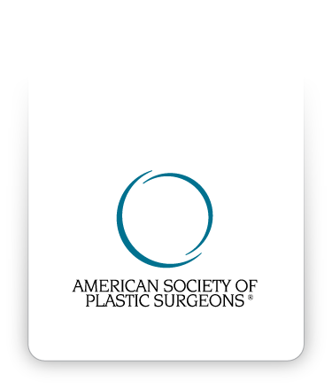

Informed Consent
Augmentation Mammaplasty
with Larger Implant than Recommended by Dr. T. Y. Steven Ip

©2012 American Society of Plastic Surgeons®. Purchasers of the Informed Consent Resource CD are given a limited license to modify documents contained herein and reproduce the modified version for use in the Purchaser's own practice only. All other rights are reserved by American Society of Plastic Surgeons®. Purchasers may not sell or allow any other party to use any version of the Informed Consent Resource CD, any of the documents contained herein or any modified version of such documents.
I, __________________________, have discussed with Dr. T. Y. Steven Ip and fully understand and accept the following with regard to my desire for breast augmentation using an implant larger than
Dr. T. Y. Steven Ip feels is optimal for my breast tissue and my body proportions.

I acknowledge that I fully understand each item listed below.

I have had an opportunity to have all my questions answered, and I feel informed and I accept each risk or tradeoff listed below as indicated by my initial(s) ________ beside each item. (Please place your initials in the blank at left, and then initial each box beside each item below).

 As I get older, my breast skin will age, stretch and become thinner even without an implant. The larger any breast, augmented or not, the worse it will look over time due to skin stretching.
 Adding any implant to my breast adds weight and will produce stretch and irreversible thinning of my breast tissues over time.
 The larger the implant, the greater the amount of breast tissue stretch that will occur.
 Adding excess weight to the breast almost guarantees that it will look worse over time, with increased stretch and sagging. It is impossible to predict whether or when this will occur in any individual patient.
 Adding weight to my breast with a large implant may cause me to need further surgery in the future, particularly mastopexy (breast lift) with additional visible scars and risks. I will incur additional costs, time off work, risks, and tradeoffs if additional surgery is necessary.
 Excessive breast tissue stretch from a large implant can make me more likely to have surgical complications with healing problems if the tissues become very thin.
 As breast tissues thin, I will definitely be able to feel my implant, portions of the implant may be visible through my skin and visible rippling or wrinkling may occur.
 If excessive stretch or complications occur (and this is unpredictable), it may even become necessary to remove the implants, with compromise in the appearance of my breasts and probable visible scarring if breast lifting (mastopexy) is necessary when the implants are removed.
 When I request implants larger than Dr. T. Y. Steven Ip feels are optimal for my tissues and body proportions, I am overruling Dr. T. Y. Steven Ip years of experience and judgment and I accept full responsibility for every possible outcome of my decision, whether that outcome or risk is known or unknown to me and to Dr. T. Y. Steven Ip, MD.
 I understand and accept all of these risks, limitations, and tradeoffs, and request that Dr. T. Y. Steven Ip proceed with larger than optimal implant augmentation of my breasts. I have had an opportunity to have all of my questions answered to my satisfaction, and am totally comfortable with my decision.

Signed this _____day of the month of ________, 20___.

_______________________________ _________________________________ __
Patient: (Please print) Witness: (Please print)

_______________________________ _________________________________ __
Patient: (Please sign) Witness: (Please sign)

