T. Y. Steven Ip, M.D.

PLASTIC SURGERY

BREAST AUGMENTATION AFTER CARE INSTRUCTIONS

- After surgery, it is important for you to have someone available to stay with you for the first 24-28 hours, as you will be weak and drowsy. You may require help the first few times you get out of bed.
- It is important to get out of bed early and often after your surgery (with assistance) to prevent postoperative problems. Please take deep breaths frequently to keep your lungs clear (15-20 per hour.) Keep your head elevated about 30 degrees (two pillows) with the knees slightly flexed.
- After surgery it is best to go to bed and elevate your head and shoulders on at least 2 pillows.
- A light diet is best after surgery. Begin by taking liquids slowly and progress to soups or Jell-O. You may start a regular diet the next day.
- Please take the pain medication only if you have pain. Take it with crackers, Jell-O, etc. You should need it the first 2-3 days after surgery every 3-4 hours. You will be given an anti- anxiety/muscle relaxant medication (Xanax) that you may take as well to prevent aggravation of the pain cycle.
- For the first 48 hours keep your arm movements to a minimum. Your arms should not be used to support your body or lift anything heavy. Do not push with your arms to lift yourself in bed.
- Infrequently small drains are used to draw off any accumulating fluid after surgery. The bulb should be kept collapsed at all times. The fluid will need to be removed from the bulb every 3 hours. Please keep a record of what time and how much fluid is emptied from the bulb. Bring this record with you to the office appointment. Usually drains are removed 48 hours after surgery. The drains will not be removed if you have drained more than 30 cc within a 24-hour period.
- You will have a steri-strip tape over your incision. This will protect the incision for 7-10 days. You can shower with the steri-strip tape on. If you have non-dissolvable sutures, they will be removed in 7-10 days and you will wear steri-strips for 3-4 weeks. (We will provide the steri-strips.) You can apply scar cream to maximize wound healing, beginning at 3 weeks. Use the cream for 6 months after surgery.
- DO NOT SMOKE. This is very important.
- You may shower 24 hours after surgery.
- You may wear a camisole or no bra after surgery. Dr. Ip will advise you when you may wear an underwire bra (usually 6 weeks after surgery.)

1

- Strenuous activities and exercises are to be avoided until 3 weeks after surgery. (heart rate should stay below 100 beats per minute.) You may gradually resume normal daily activities after 48 hours being careful to avoid any activity that causes pain or discomfort.
- Driving may be resumed when a sharp turn of the steering wheel will not cause pain; this is usually within 5-7 days.
- Breast implant massage should start on post-op day one after surgery. An illustration is provided and the nurse or Dr. Ip will show you how to perform these breast exercises. The importance of the breast exercises cannot be over emphasized. They help to prevent capsular contractures and promote healing of the chest muscles. You should be committed to doing these exercises on each breast three times daily.
- All incisions will be extremely sensitive to sunlight during the healing phase. Direct sun contact or tanning booths are to be avoided and use a sunscreen with SPF of 15 with UVA and UVB protection for at least 6 months. The incision scars can be massaged with a moisturizing cream, vitamin E, or aloe vera cream starting 3 weeks after surgery. This will promote early softening and maturation of these areas.

WHAT TO EXPECT AFTER SURGERY

Sensations like numbness, sharpness, and burning are common during the healing process.
These sensations may last several weeks and will gradually disappear.
Bruising and swelling are normal for 2-3 weeks. It will disappear over time.
You will initially feel like your implants are too high and too large. This will resolve over the first 4-6 weeks post operatively.

Please note

If you have nausea, vomiting, rash, shortness of breath, or diarrhea after taking your medications, please call our office.
If you develop a fever (oral temperature greater than 100°), redness and/or increased pain at the surgical incision sites, please call Dr. Ip immediately.
If you have major dental work or major surgery, please notify Dr. Ip so he can prescribe a pre-operative medication to protect your implants from possible infection.

2

BREAST EXERCISES
These exercises help to prevent capsular contractures (the development of scar tissue around the implant) and also help promote healing. The exercises should be performed 3 times daily for the first 9 months and then 1 time daily for life. The breast should be pushed gently and held in position of a few seconds before release. To create more cleavage it is okay to avoid pushing
the implants to the side (laterally).

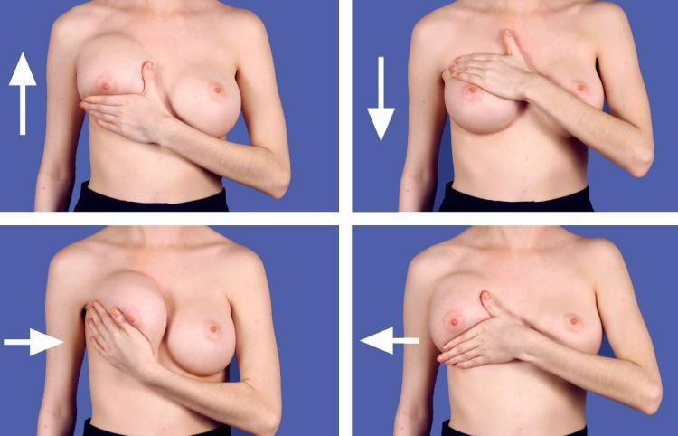

* Call our office if you have any questions, if problems should arise, or if you have been having any signs or symptoms of infection (redness, fever, drainage) Newport Beach Office (949) 548-0300 or Park Avenue NYC Office (855) 742-8800

3
Please visit Dr. Ip’s website at www.surgery-plasticsurgeon.com for additional information on plastic surgery and wellness..

It is important to be seen by Dr. Ip after your initial post-op checks. He will see you at scheduled follow-up appointments. Call to schedule your appointments at Newport Beach Office at (949) 548-0300 or Park Avenue NYC Office (855) 742-8800 between the hours of 8:30 – 6:00.

IF YOU HAVE ANY QUESTIONS, PLEASE CALL DR. IP
If you are a patient at one of the facilities below, please call between the hours of 8:30-6:00. If you need immediate care, please call Dr. Ip anytime on his cell. There is no such thing as a minor question. I would rather you call me than wonder and not do the right thing, so please call my office, or email me anytime.

Dr. Ip’s cell: (949) 212-1619
Dr. Ip’s email: tystevenipmd@mindspring.com
Dr. Ip’s website: www.surgery-plasticsurgeon.com

Newport Beach Office:
351 Hospital Road, Suite 319 Newport Beach, CA 92663 (949) 548-0300

Park Avenue NYC Office: 799 Park Avenue
New York, NY 10021 (855) 742-8800

4

